|  |  |  |  |  |  |
| --- | --- | --- | --- | --- | --- |
| **School of Electronics Engineering (SENSE)** | | | | | |
| **“J” COMPONENT REVIEW-II REPORT** | | | | | |
| **COURSE CODE / NAME** | ECE3003 – MICROCONTROLLERS & ITS APPLICATIONS | | | | |
| **PROGRAM / YEAR / SEM** | B.Tech (ECE/ECM)/II Year / Fall 2018-19 | | | | |
| **DATE OF REVIEW** | 25/02/2019 | | | | |
| **J TITLE** | RFID BASED ATTENDANCE SYSTEM | | | | |
| **TEAM MEMBERS**  **DETAILS** | **REGISTER NO.** | | **NAME** | | |
| 17BEC1046 | | P. ILLAVENIL | | |
| 17BEC1068 | | KISHORE NITHIN S | | |
| 17BEC1107 | | S RAMNATH | | |
| 17BEC1217 | | N. HARIHARASUBRAMANIAN | | |
| **EVALUATION ITEMS** | | | | | **Yes ( √ ) / No ( x )** |
| The project has achieved the objective set for this point? | | | | |  |
| Level of Knowledge Gained While Completing the Project was satisfactory? | | | | |  |
| Are the students having clear idea on their proposed and have they acquired to carry forward it? | | | | |  |
| Are the contribution made by the individuals towards attaining objective of the project was satisfactory? | | | | |  |
| Are the submitted report and presentation made by each team member was satisfactory? | | | | |  |
| **COURSE INCHARGE NAME** | | **Prof. V. PRAKASH** | | **MARKS** |  |
| **REVIEWER’S NAME & SIGN** | |  | | | |

**Objective of the Project:**

* The objective of the project is to build an attendance system using 8051 Microcontroller which uses RFID Tags for identifying the student and storing his/her attendance entry in the microcontroller.
* The project additionally displays all the attendance entry in the microcontroller through an LCD Module.

**Components Required:**

|  |  |  |  |  |
| --- | --- | --- | --- | --- |
| **S. No** | **Component Name** | **Specification** | **Quantity** | **Cost** |
| 1 | **Push button** |  | 2 | 10 |
| **2** | **Rfid reader** | **EM-18** | **­­­1** | **600** |
| **3** | **Microcontroller** | **at89c51** | **1** | **60** |
| **4** | **LCD display** | **16*2** | **1** | **80** |
| **5** | **Crystal oscillator** | **110.0592MHZ** | **1** | **10** |
| **6** | **resistor** | **10k** | **2** | **1** |
| **7** | **capacitor** | **10u** | **1** | **10** |

**Overall cost of the Project:800(in Rupees)**

**Block Diagram:**

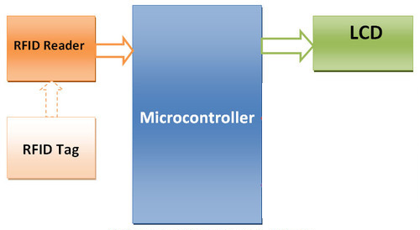

**Schematic Diagram:**

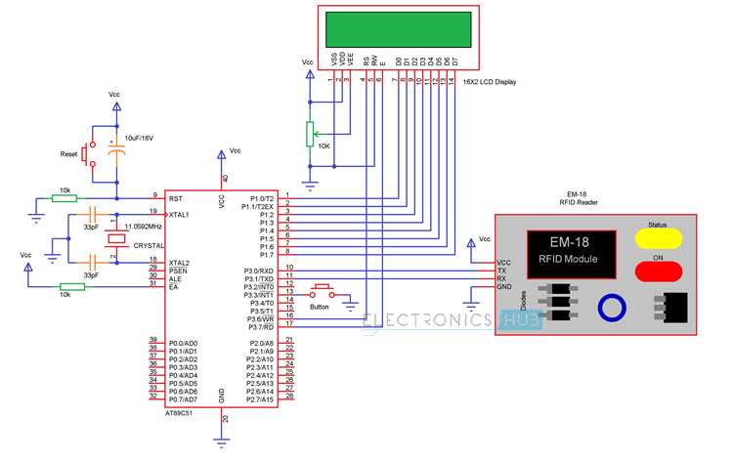

**Project Description:**

The aim of this project is to design an RFID Technology based Attendance System using 8051 microcontroller, in which the attendance of students or employees is automatically recorded with the swipe of a card. The working of the project is explained here.

When this circuit is powered ON, initially the microcontroller will display the message as Swipe the card on the LCD display. When the RFID reader detects the ID card, it will send the unique card no to the microcontroller via serial terminal.

With the help of suitable programming, we need to compare the received card no. with the numbers that are already stored in the microcontroller or any database.

Once, if any of these numbers are match with the received card no., then the corresponding name stored in that no. is displayed on the LCD display and also the attendance for the name stored in the corresponding number is marked.

By pressing the button, the attendance recording will be closed and the details are displayed on the LCD repeatedly until the microcontroller has been reset.

**Flow chart:**

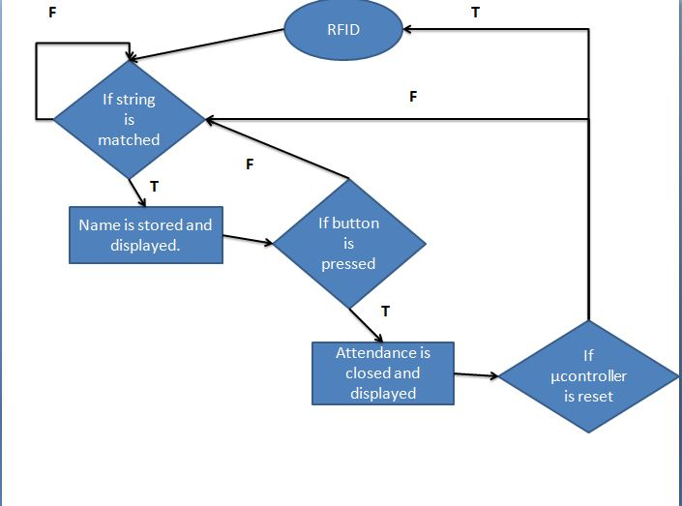

**Program:**

#include<reg51.h>

#include<string.h>

#define lcd P1

sbit rs=P3^6;

sbit e=P3^7;

sbit button=P3^3;

static char t=0,b=0,r=0,a=0;

void delay (int);

void cmd (unsigned char);

void display (unsigned char);

void string (char *);

void init (void);

void uart (void);

void list (void);

void list1 (char);

unsigned char rx (void);

void delay (int d)

{

unsigned char i=0;

for(;d>0;d--)

{

for(i=250;i>0;i--);

for(i=248;i>0;i--);

}

}

void cmd (unsigned char c)

{

lcd=c;

rs=0;

e=1;

delay(5);

e=0;

}

void display (unsigned char c)

{

lcd=c;

rs=1;

e=1;

delay(5);

e=0;

}

void string (char *p)

{

while(*p)

{

display(*p++);

}

}

void init (void)

{

cmd(0x38);

cmd(0x0c);

cmd(0x01);

cmd(0x80);

}

void uart (void)

{

TMOD=0x20;

SCON=0x50;

TH1=TL1=253;

TR1=1;

}

unsigned char rx (void)

{

while(RI == 0 && button == 1);

if(RI != 0)

{

RI = 0;

return SBUF;

}

else

list();

}

void list (void)

{

cmd(0x80);

string("Details..... ");

while(1)

{

cmd(0xc0);

string("Anusha - ");

list1(a);

delay(2000);

cmd(0xc0);

string("Bala - ");

list1(b);

delay(2000);

cmd(0xc0);

string("Ravi - ");

list1(r);

delay(2000);

cmd(0xc0);

string("Teja - ");

list1(t);

delay(2000);

}

}

void list1 (char z)

{

if(z==1)

string("Present");

else

string("Absent ");

}

void main()

{

unsigned long int i=0;

unsigned char temp1[13],temp=0;

unsigned char teja[13]="13006F8C7282";

unsigned char bala[13]="13004993E32A";

unsigned char ravi[13]="13006FF259D7";

unsigned char anu[13]="13004A29E191";

P2=0x00;

init();

uart();

button=1;

string(" Electronics ");

cmd(0xc0);

string(" Hub ");

delay(3000);

cmd(0x80);

string(" Electronic ");

cmd(0xc0);

string(" Attendance ");

delay(3000);

cmd(0x01);

while(1)

{

cmd(0x80);

string("Swipe the card ");

for(i=0;i<12;i++)

{

temp1[i]=rx();

}

temp1[i]='\0';

if(strcmp(temp1,teja)==0)

{

cmd(0x80);

string("Welcome teja ");

t=1;

delay(2000);

}

else if(strcmp(temp1,bala)==0)

{

cmd(0x80);

string("Welcome bala ");

b=1;

delay(2000);

}

else if(strcmp(temp1,ravi)==0)

{

cmd(0x80);

string("Welcome ravi ");

r=1;

delay(2000);

}

else if(strcmp(temp1,anu)==0)

{

cmd(0x80);

string("Welcome anusha ");

a=1;

delay(2000);

}

else

string("wrong card........");

}

}

**Simulation Output:**

**Implementation Output:**

**Inference:**

The project was built on the breadboard after the Proteas simulation of the circuit and was found to be working.

**Concepts Learned:**

Working of RFID Module

Working of LCD Module

Timers and Serial Communication in 8051

**Applications:**

* RFID based attendance system can be used in educational institutions, industries, anywhere.
* RFID is emerging technology and is used in applications where authentication is needed.

**Difficulties faced:**

**Proteas Simulation**: Since Proteas was a new software and so we had to learn it on our own within limited time and obtain the correct simulation for the project.

**Timeline:**

**January:** Circuit Design, Proteas Simulation.

**February:** Procuring the components from the market and building the circuit on breadboard.

**March:** PCB Design and construction of PCB Circuit.